Power BI

Assignment – 1

**Q1) Install Power BI Desktop and share the final screenshot of the report view page which appears when power desktop starts.**

A – Power BI desktop application installed successfully and please find the below Screenshot for your reference.

**Power BI Desktop Home Page**

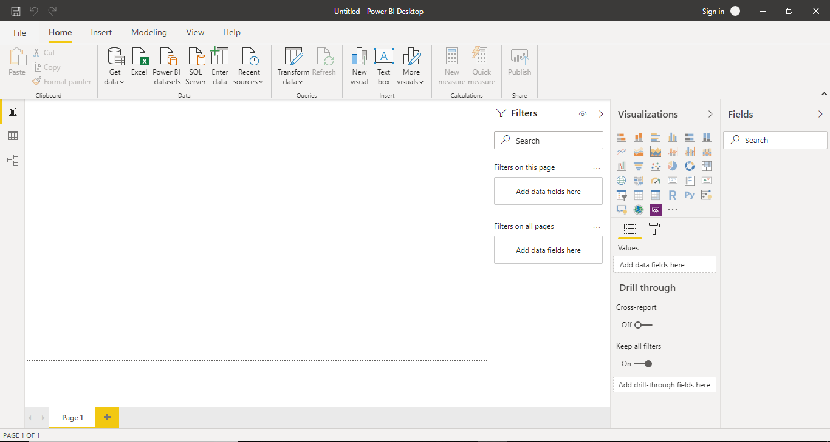

Q2) Prepare a document and with the following screenshot

**− Report View**

A **Power BI report** is a multi-**perspective view** into a dataset, with visuals that represent different findings and insights from that dataset. A **report** can have a single visual or pages full of visuals.



**− Data View**

**Data view** helps you inspect, explore, and understand **data** in your **Power BI** Desktop model. It's different from how you **view** tables, columns, and **data** in **Power Query** Editor. With **Data view**, you're looking at your **data** after it has been loaded into the model.

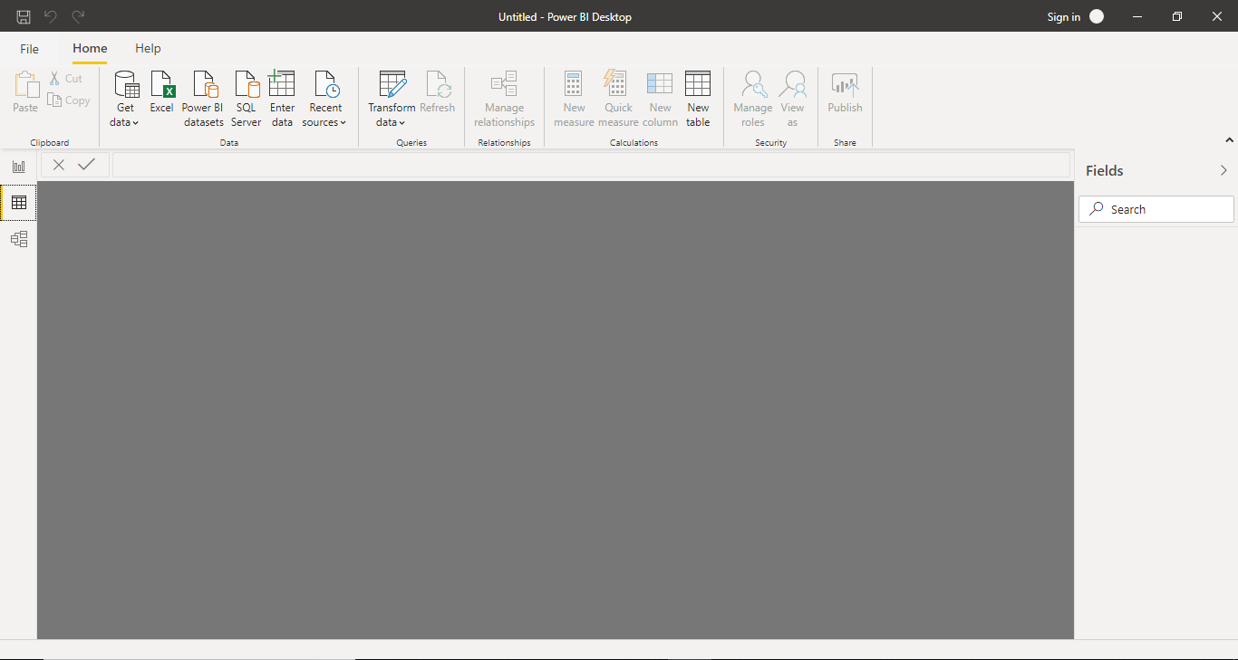

**− Model View**

**Model View** helps to create connection or relation between **fact tables, reference tables and measures tables** based on the data sets present inside the tables.

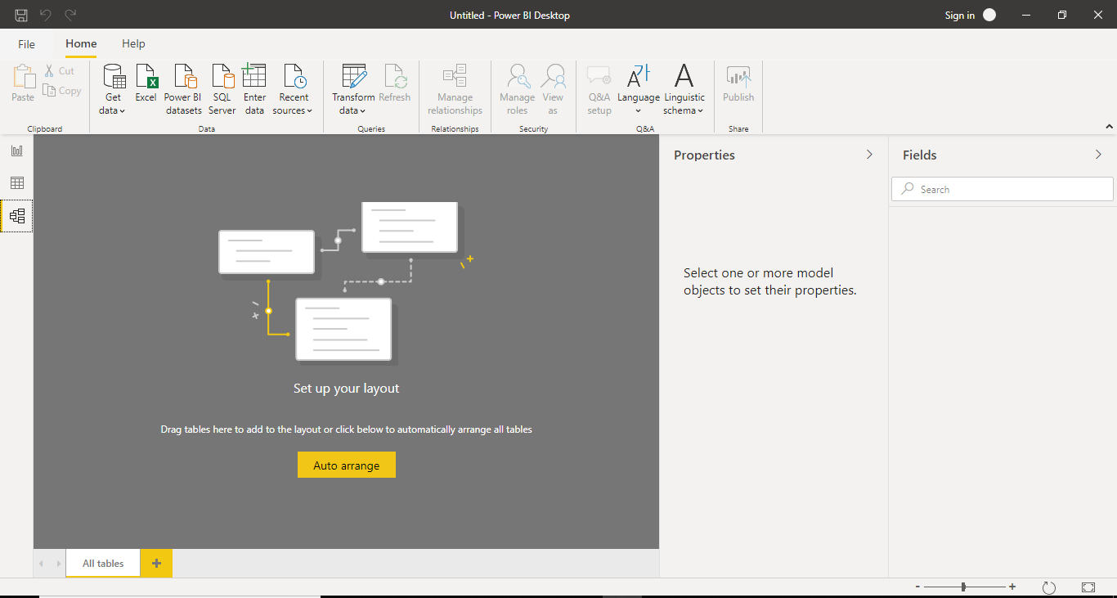

**− Power Query Editor**  
The **Query Editor in Power BI** is used to transform or edit data files before they are actually loaded into the **Power BI**. The **Query Editor** plays the role of an intermediate data container where you can modify data by selecting rows and columns, splitting rows and columns, pivoting and unpivoting columns, etc

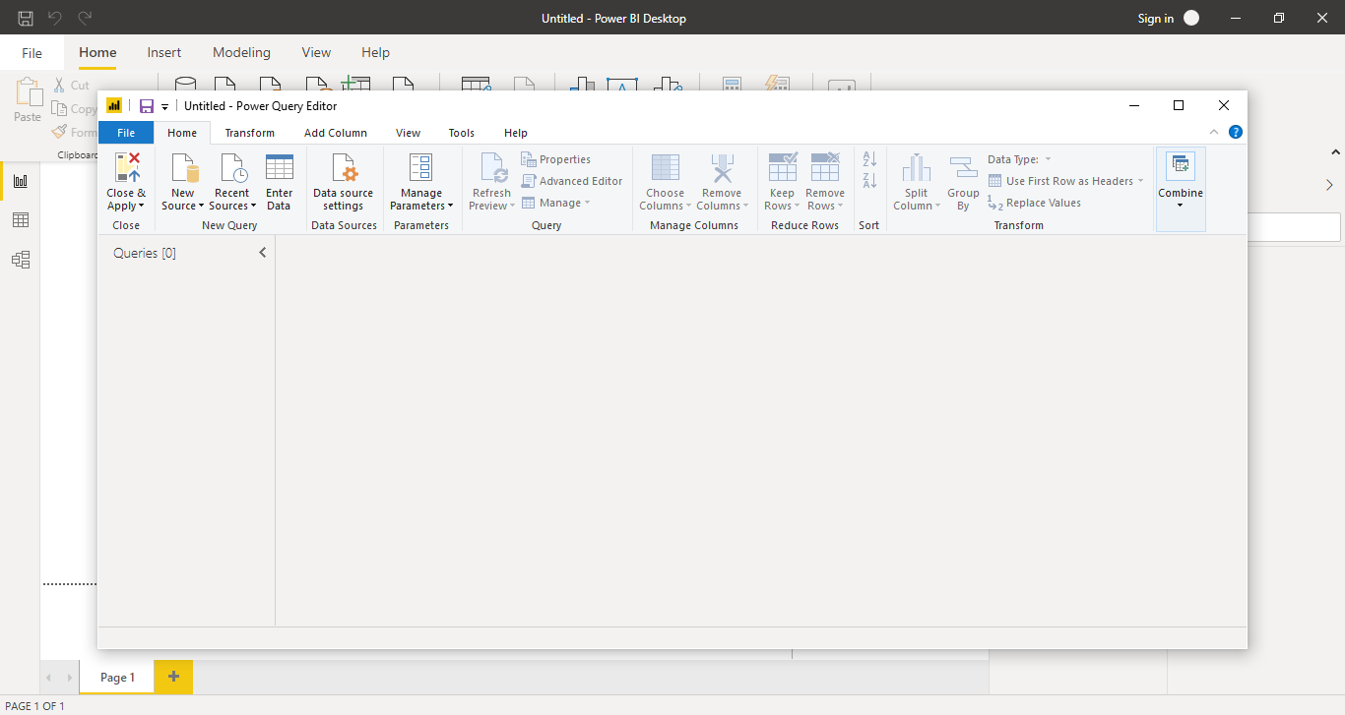

**− Advance Editor**

The **Advanced Editor** lets you see the code that **Power Query Editor** is creating with each step that we are performing during the time of data transformation.

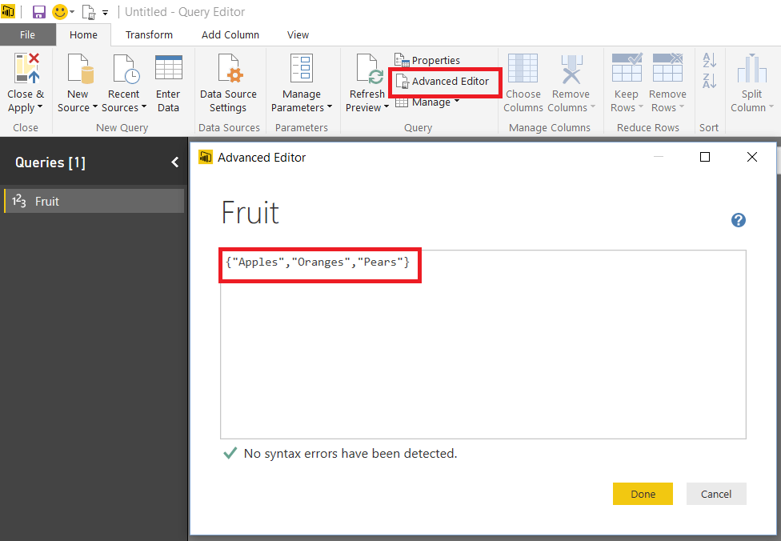

• Prepare a document with details of the following along with their price

**− Power BI Desktop**

Power BI Desktop*is a free application, where we can install on our local computer allows us connect different source data, transform, and visualize your data. With Power BI Desktop, we can connect to multiple different sources of data, and combine them (often called*modelling*) into a data model. This data model lets us to build visuals, and collections of visuals we can share as reports, with other people inside our organization. Most users who work on business intelligence projects use Power BI Desktop to create reports, and then use the*Power BI service*to share their reports with others.*

**− Power BI Pro**

**Power BI Pro** is an individual user license that lets users read and interact with reports and dashboards that others have published to the **Power BI** service. Users with this license type can share content and collaborate with other **Power BI Pro** users.

 The **Pro** plan **costs** $9.99/user/month. It includes data collaboration, data governance, building dashboards with a 360-degree real-time view and the ability to publish reports anywhere. Users can try it a free trial for 60 days before purchasing the subscription.

**− Power BI Premium**

**Power BI Premium** is a capacity-based offering that includes: Flexibility to publish reports broadly across an enterprise, without requiring recipients to be licensed individually per user. Greater scale and performance than shared capacity in the **Power BI** service

**Premium** capacity, you must also have a **Power BI** Pro license. Therefore, the minimum cost of entry is $4,995 (P1) plus $9.99 (Pro) for a total of $5,004.99 per month.